**Assignment**: (Spring MVC) - Assignment ID:10_Spring_Assignment3

Develop Web application to facilitate the below operations using Spring Web MVC Integrating with **hibernate**

a. Add a Book

b. Delete a Subject

c. Delete a book

d. Search for a book

e. Search for a subject

f. Exit

**Code**:



**Web Page Screenshots (Angular and Webservice)**:

**Subject Book List**

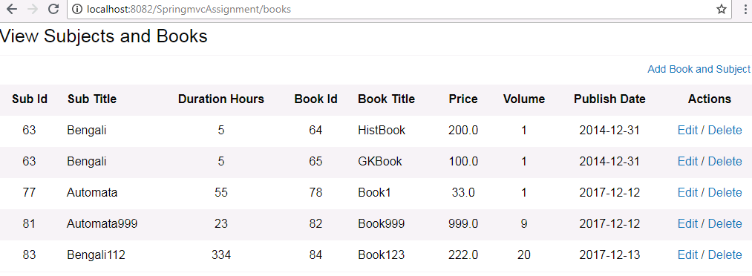

**Subject Book Add Page**

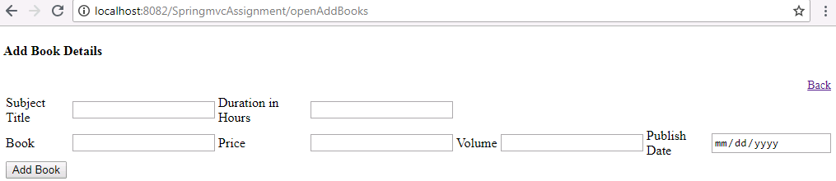

**Subject Book Edit Page**

